Oddington Parish Council
Dark Skies Policy Statement 2024
Oddington currently enjoys a low level of light pollution which the Parish Council wishes to preserve and where possible, improve upon. At the 2024 Parish Meeting dark skies emerged as being one of the reasons our resident enjoy living in the village. The Parish Council subscribes to the Dark Skies movement and seeks firstly to avoid and secondly to minimise light pollution.
This statement supports the National Planning Policy Framework. This states that all planning policies and decisions should limit the impact of light pollution from artificial light on local amenity, intrinsically dark landscapes and nature conservation. Below are various forms of light pollution and mitigation measures that might be undertaken. The Parish Council will resist strongly obtrusive forms of exterior lighting and encourage householders to be thoughtful in the use of interior lighting particularly where it might have an impact on their neighbour.
This good lighting guidance is based on guidance produced by the Commission for Dark Skies www.britastro.org/dark-skies and has been adopted by Oddington Parish Council as being good practice. Efficient and environmentally sensitive lighting benefits wildlife, lessens harmful effects on human health, saves energy and money, slows climate change, means better safety and security and enhances our view of the inspiring night sky.
What is light pollution and how can it be minimised?
Light pollution is the result of unwanted and wasted light illuminating the sky. It consists of four aspects:
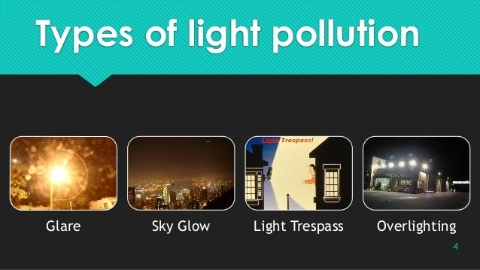

Glare. Discomfort results in a loss of visual performance when presented with a light source brighter than the level to which we or creatures are accustomed. Hence the loss of vision when people don’t dim their car headlights and use high intensity security lights.
Sky glow or ambient light. This is caused by lighting being emitted upwards, and by a scattering of artificial light by airborne dust and water droplets, creating a pink and orange glow which can be seen for miles around urban areas. Sources of this artificial light are principally street and large-scale industrial lighting.
Light spillage and trespass. Light can ‘stray’ from its intended purpose spilling beyond the boundary of the property on which it is located becoming an annoyance because of glare or intrusion.
Overligthing occurs when something is illuminated too brightly or thoroughly.
What can we do?
• Turn off exterior lights - don’t leave porch or security lights burning all night long.
• Use exterior lighting which is controlled by a sensor.
• Reduce spillage from windows and roof lights – use thick curtains or blackout blinds.
• Light only what is necessary – trip hazards, steps.
• Use carefully directed lighting using cones, shades, and appropriate aiming angles to ensure that light is only shone in the direction needed.
• Do not use upward facing ground lights or illuminated bollards.
• Be careful of colour temperatures – LED lights are typically high. Aim for lights with a colour temperature of between 1750 - 3000 Kelvin This will minimise the more harmful blue wavelengths.
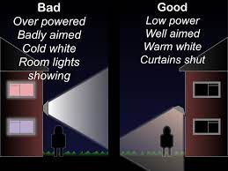
Blue-rich white lighting
New and existing white-light sources are often far too bright for the lighting task. This harsh blue-white light reflects from surfaces and scatters high into the atmosphere. Even though the lights may be downward directed, they can still cause sky-glow and environmental damage through reflected light. People often complain about harsh white road lights and prefer warm white or amber LED colours. To avoid negative effects, all exterior lights should have a colour temperature less than 3000 Kelvin as a default specification.
Home lighting
Many of the new LED lights are very inefficient, casting light over a wide area, not just where it is required. Use only floodlighting that has sensors to turn it off when not needed, and which lights only where needed. This will improve neighbours’ wellbeing, avoid glare to pedestrians and traffic, and make wrongdoers more visible. According to the UK Government crime-prevention website, much floodlighting is “…unfortunate, as in many locations it is inappropriately installed and other forms of lighting could make for a better choice”. Poorly aimed floodlighting has been implicated in fatal accidents caused by glare.

