Oddington
A Plan for our Village

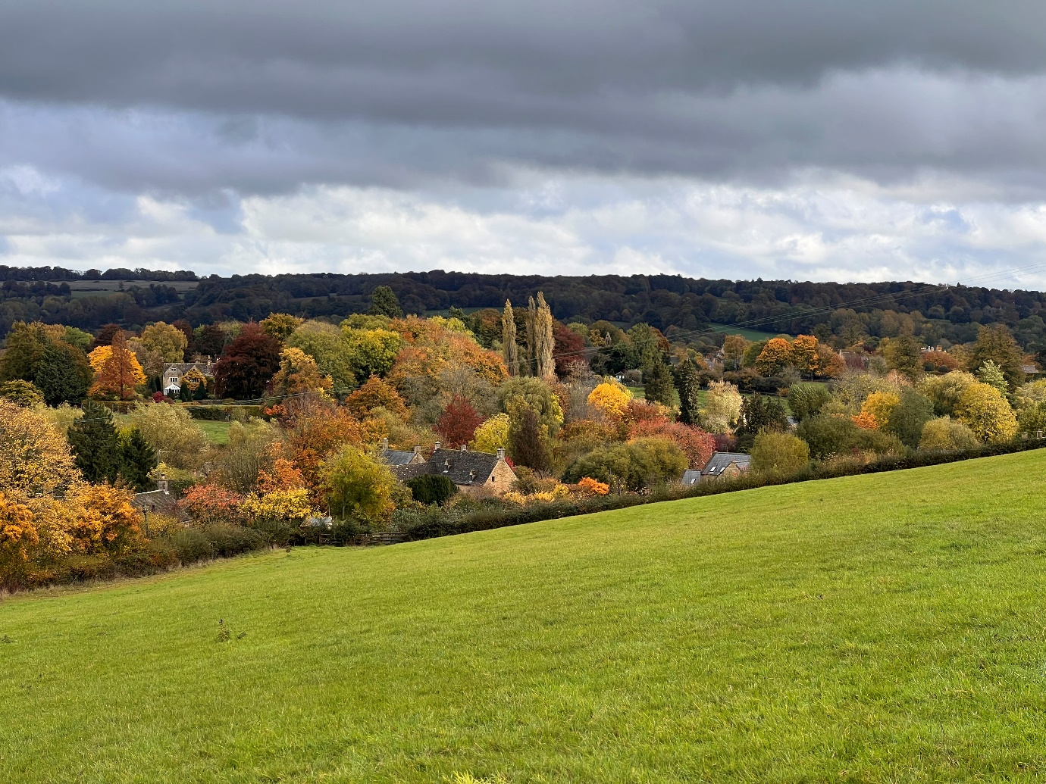

This is a draft document. You are invited to send any comments to Janet at parishclerk@oddingtononline.net by the end of August.

Issued by Oddington Parish Council
www.oddingtononline.net

Oddington
A Plan for our Village
Foreword
Planning and changes to our more traditional village life have become major issues as the challenges of a rural area of outstanding natural beauty in a conservation area meet head on the highly desirable and popular destination in which we fortunate to live. The amount of change is considerable and Oddington Parih Council has found itself having to be reactive to a number of developments and changes. In response OPC looked at the “statutory” and other plans that could be adopted. Some larger communities and settlements have, or are, adopting Neighbourhood Plans which have statutory force and Village Design Statements which do not, as a means of expressing the concerns of their community. Unfortunately the planning system is under immense pressure and the two Local Authorities who serve us are racing to get long term plans approved so that they can maintain ‘control’ of development and meet the perceived housing demand.
BUT what can we do?
We are too small to embark on a Neighbourhood Plan which would be costly and could well be undermined by national planning policies and our Village Conservation Area statement is now some 20 years old. But we do need to be proactive to do everything possible to:
- retain the distinctive character of the village of Oddington
- build community resilience in the light of increasing large scale development in our neighbouring market towns and second homes and holiday lets in our village
- protect the conservation area
This is our evolving village plan – thank you to all who have contributed to date. We would welcome more comments on this draft. When finalised, the plan will guide us in navigating the future. We will pursue it vigorously with the principal authorities and developers. We will keep it updated to reflect the views of all the residents.
David Thorpe
Chairman, Oddington Parish Council
July 2024

**********************************
Introduction
Parish Councils are the first tier in local government. Oddington Parsh Council comprises seven Councillors, elected every four years, and one, part time, employee. The Council raises an annual precept (Rates) of £8,000 and applies for grants for projects.
The Council:
- owns and maintains the three village greens, the defibrillators and the playground equipment.
- employs a contractor to cut the greens and the verges and uses volunteers to carry out other maintenance work
- seeks to influence Cotswold District Council and Gloucestershire County Council to secure the best outcome for the village
- Is a statutory consultee, but not decision maker, on planning applications
- organises the annual service of Remembrance at the War Memorial, the Christmas Lights and other special events
- issues a monthly e-newsletter and runs the village website www.oddingtononline.net.
In May 2024 the Council arranged a consultation exercise inviting residents to set out their priorities for the village. This plan sets out how the Council will take forward the points that were raised.

- The Village scene
You told us that you are concerned about the way the village looks.
Verges are part of the Highway and belong to Gloucester County Council (GCC). It is illegal to place obstructions on verges to protect them but where possible we will:
- work with GCC to reinstate damaged verges and granite kerb sets
- continue to mow the verges and greens and, annually, to clear the bank in Upper Oddington
- with volunteers, plant more spring flowering bulbs
Formal Parking restrictions require a Traffic Regulation Order (TRO) from GCC. We will continue to seek to find solutions without recourse to a TRO by:
- working with the owners of the Fox to encourage more considerate parking in Lower Oddington
- monitor the situation elsewhere in the village
Street furniture can be unsightly. We will:
- inspect all the signs, litter bins and benches in the village and remove those no longer needed
- introduce a programme of refurbishment of remaining street furniture and purchase new items if necessary
We will encourage residents to report potholes, overgrown footpaths, blocked drains and other highway problems to GCC using the web site FixMyStreet.
We will explore with landowners the possibility of a community orchard and more hedge planting.
- Speeding
You told us that you are concerned about speeding though the village. We will:
- explore with GCC the possibility of introducing a 20mph speed limit. This will require a Traffic Regulation Order (TRO)
- investigate the possibility of introducing traffic calming measures that do not require a TRO
- Consider what can be done to encourage cyclists to exercise more care when riding through the village

- Community
You told us that we need to do more to welcome newcomers and weekenders to the village and to develop a strong community. We will:
- prepare a ‘welcome letter’ for distribution by Councillors to those newly arrived in the village
- work to establish a group of volunteers to provide a first point of contact and to carry out door to door leaflet drops
- support and encourage events which aim to integrate weekenders
- encourage individuals to establish special interest groups in the village. The Council may be able to provide modest financial support to help such groups get off the ground
- find volunteers willing to take on the role of Neighbourhood Watch co-ordinator
- arranging evets such as the annual litter pick

- Planning and Housing
You told us that:
- the Village Conservation Area should be protected. We will therefore object to any planning application within the Conservation Area which does not follow the local vernacular design and which does not use traditional materials. We will also oppose any application which results in infilling of the open spaces in the Conservation Area.
- light pollution is increasingly of concern. We will join the CPRE Dark Skies campaign and encourage residents and business to adopt the Lighting Guidelines. We will prepare an information sheet to distribute to residents.
- second homes should be limited. We will establish what controls Cotswold District Council can impose and lobby for more if we feel that is appropriate.
- where necessary we should employ professional advice to help the Council respond to major planning applications. We will consider this if we feel that the impact of an application justifies the cost.

- Communications
You told us that communication is important. We will:
- promote and develop the e-newsletter to make it the primary source of news. We will make hard copies available at the Book Exchange for those who do not use the internet.
- promote other forms of social media including the village website and Facebook sites
- use volunteers to carry out door to door leaflet drops where appropriate.

- Working together
The village is very fortunate in having two churches and a well-equipped Village Hall. We will work with the Village Hall Committee and the church wardens to:
- promote activities taking place in these venues and elsewhere in the village
- help with the organisation of social and fund raising activities by arranging road closures, licences, risk assessments and event plans.

If you would like to comment on this plan please email, by the end of August the Parish Clerk, on parishclerk@oddingtononline.net or contact one of the Parish Councillors.
Contact details, together with details of Parish Council meetings and finances can be found at www.oddingtononline.net

